

MONITORING REPORT
JANUARY – SEPTEMBER 2018

CROSS-SECTOR JUSTICE STRATEGY 2017-2020

www.drejtesia.gov.al

Tabela e Përmbajtjes

I. Executive summary on the monitoring of the Cross-sector Justice Strategy 2017-2020 and Action Plan for the period January – September 2018 4
- Executive summary on justice reform system 6
II. Monitoring methodology 10
III. Financial disbursement 11
IV. Progress of implementation by objectives 12
Objective 1: Strengthening independence, efficiency, effectiveness and accountability of the justice system institutions. 12
Objective 2: Consolidating legal education and training as well as specialising magistrates and court personnel 14
Objective 3: Improving the functioning of the judicial system by strengthening its efficiency, transparency and accessibility in accordance with European standards. 15
Objective 4: Increasing the efficiency of the criminal justice system and anti-corruption measures through the consolidation of the mission, status and functions of criminal justice institutions. 16
Objective 5: Improving the functioning of the system by providing electronic systems procedures and facilities for development of strong international cooperation 17
Objective 6: Enhancing protection of human rights in the penitentiary system 18
Objective 7: Improving the functioning of the Ministry of Justice and its newly established or deeply changed subordinate institutions.. 19
Objective 8: Improving the service quality of legal professions and establishing a legal framework for arbitration. 20
V. Main achievements during the period January - September 2018…..…………………….…… 21
VI. Need to review the Action Plan of the Cross-sector Justice Strategy 24
VII. Conclusions 24
VIII. Challenges 25
Annex 1 – Progress over the 27 laws of the justice reform package..................................................26

LIST OF ABBREVIATIONS

NAIS National Agency of Information Society
ALBIS Electronic judicial enforcement case management system
AP People's Advocate
SAJS State Archive of the Judicial System
GDP General Directorate of Prisons
GDE General Directorate of Enforcement
NCA National Chamber of Advocates
NCM National Chamber of Mediators
NCPJB National Chamber of Private Judicial Bailiffs
CC Constitutional Court
HC High Court
HJI High Justice Inspector
FMI Forensic Medicine Institute
JAC Justice Appointments Council
HCJ High Council of Justice
HJC High Judicial Council
HPC High Prosecutorial Council
CoM Council of Ministers
ACAC Albanian Child Adoption Committee
SCLA State Commission for Legal Aid
MoJ Ministry of Justice
MFE Ministry of Finance and Economy
GPO General Prosecutor's Office
AP Action Plan
OPC Official Publications Centre
SND Cross-sector justice strategy 2017-2020
SPAK Special Anti-Corruption Structure
SoM School of Magistrates
PS Probation service
DCM Decision of the Council of Ministers
OAJB Office of Administration of Judicial Budget

EXECUTIVE SUMMARY ON THE MONITORING OF THE CROSS-SECTOR JUSTICE STRATEGY 2017-2020 AND ACTION PLAN FOR THE PERIOD JANUARY – SEPTEMBER 2018.

The Cross-Sector Justice Strategy 2017-2020 and its Action Plan was adopted by Decision of the Council of Ministers 773 dated 02/11/2016.

The mission of this strategy is the successful implementation of reforms in the justice sector, in order to ensure an effective, efficient, independent and transparent justice system in accordance with the European best practices.
The Strategy consists of eight high-level strategic objectives, which are:

- Strengthening independence, efficiency, effectiveness and accountability of the justice system institutions.
- Consolidating legal education and training as well as specialisation of magistrates and court personnel.
- Improving the functioning of the judicial system by strengthening its efficiency, transparency and accessibility in accordance with European standards.
- Increasing efficiency of criminal justice system and anti-corruption measures by consolidating the mission, the status and the functions of criminal justice institutions.
- Improving the functioning of the justice system by providing modern electronic system procedures and facilities for development of strong international cooperation.
- Enhancing protection of human rights in the penitentiary system.
- Improving the functioning of the Ministry of Justice and its subordinate institutions.
- Improving the service quality of legal professions and establishing a legal framework for arbitration.

This report is drafted in the framework of the implementation of the Action Plan for the Cross-cutting Justice Strategy 2017-2020 and constitutes the third monitoring report. The report covers progress during the period from 1 January 2018 to 30 September 2018. In order to monitor the achievements, progress and/or challenges in the context of fulfillment of the objectives of the strategy, the information was provided by the contact points of each responsible institution regarding the implementation of the NSD.
The Action Plan consists of the 8 above-mentioned objectives and it contains 201 sub-activities . In order to monitor the fulfilment of the commitments undertaken concerning the implementation of the sub-activities, the monitoring process is focused on the level of objectives. The assessment of the level and status of implementation of sub-activities of SND is based on the information provided by each responsible unit. Ministry of Justice assessed the information during October 2018. Based on the overall assessment of the reporting for the period january - september 2018, the level of implementation of the measures of the Action Plan is as follows:
Progress towards each objective
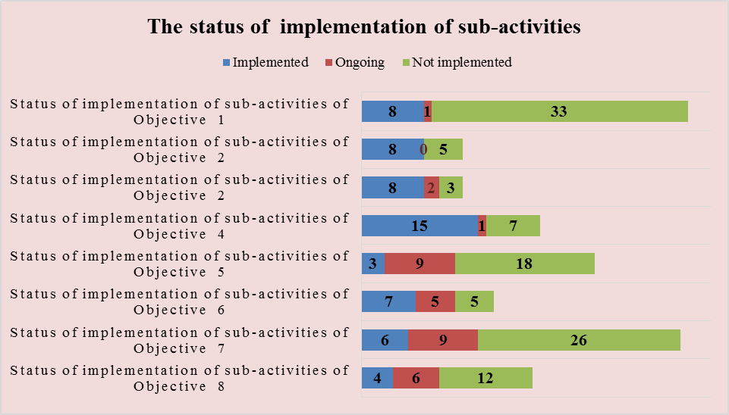
Status of implementation of sub-activities by Objectives
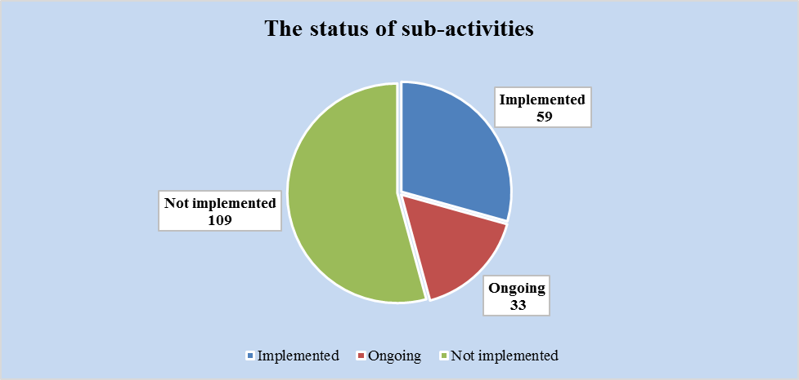
So far, out of 201 sub-activities foreseen in the Action Plan of the Strategy 59 are implemented, 33 are ongoing and 109 sub-activities are not implemented (65 sub-activities of which fall under the scope of responsibility of new institutions of the justice system, that are not established yet). The percentage against the total progress of implementation of the Action Plan is 29% for the implemented sub-activities, 17% for the ongoing activities and 54% for the activities which will start to be carried out in the future by the responsible institutions.

- EXECUTIVE SUMMARY ON JUSTICE REFORM SYSTEM

Legislation progress
Recently, justice system in Albania has been subjected to deep reforms in order to fulfil European standards in this system. Following adoption of law no. 76/2016 “On some addenda and amendments to law no. 8417/1998 “Constitution of the Republic of Albania” amended, Albania started to implement the justice reform. The constitutional amendments and the package of the organic laws adopted in the framework of the justice reform contain clearly defined provisions that guarantee independence, impartiality, professionalism, integrity of the judicial system, as well as improvement of accountability and monitoring mechanisms of its functioning. Furthermore, a package of 27 laws is planned to be adopted, to cover all the aspects of the judicial reform. So far, the Parliament has passed 17 laws, 10 draft laws are pending, 4 of which have been withdrawn from the adoption process.
In May 2018, Parliament of Albania adopted law no. 26/2018 “On some addenda and amendments to law no. 10385, dated on 24.02.2011 “On mediation in dispute settlement”. This law sets out: a) general principles of mediation; b) disputes where mediation is applicable; c) organization and functioning of bodies provided by this law; d) the rights, obligations and responsibilities of the mediator.

The law also defines the duties of the Minister of Justice, who exercises the following functions: a) grants the mediator's license; b) commences the disciplinary proceeding, according to letter "b", of article 11/3 of this law, as well as decides regarding the disciplinary measure for the revocation of the license for the exercise of the profession of mediator; c) supervises, through the structures of the Ministry of Justice, the implementation of this law and other legal and sub-legal acts related to the activity of mediators; d) adopt the rules and procedures for recognition of the title of mediator acquired in a foreign state. ".
In July 2018, Parliament of Albania adopted law no. 55/2018 “On the advocate profession in the Republic of Albania”.This law aims to protect and guarantee the exercise of the profession of lawyer in the Republic of Albania as a freelance, independent, self-regulated and self-administered profession in the function of protecting the individual and collective interests of the subjects it represents.

Governance institutions of the Justice System

Justice reform has introduced important changes to the institutional definitions of the Albanian judiciary. The existing institutions are modified and new institutions are established based the constitutional amendments and the specific organic laws mentioned above.

Referring to the competence of the Ministry of Justice in the judicial system, information is given above, related to the legal development of the justice reform. Moreover, the Ministry of Justice, upon the entry into force of the law no. 96/2016 dated 06.10.2016 “On the status of judges and prosecutors” has no longer the competence to inspect the activity of the prosecutor’s offices and courts of first instance and appeal concerning the investigation of disciplinary violations and making recommendations for the disciplinary proceedings in the case of prosecutors and judges. Following the entry into force of this law (22.11.2016), any complaint or information, which following the preliminary verification results in reliable indicia of violation of the activity by the magistrate, shall be sent for further verification and follow-up procedures of the HCJ and/or Prosecutor General.

The newly established institutions and those foreseen to be established are the following:
- Justice Appointments Council (JAC) - Constitution and law no. 115/2016.
- High Judicial Council (HJC) - Constitution and law no. 115/2016.
- High Prosecutorial Council (HPC) - Constitution and law no. 115/2016.
- High Justice Inspectorate (HJI) - Constitution and law no. 115/2016.
- Special Prosecutor’s Office against corruption and organised crime - Constitution and law no. 95/2016.
- Special Investigation Unit/National Bureau of Investigation - Constitution and law no. 95/2016.
- Court against corruption and organised crime - Law no. 95/2016.
- Judicial Council - Law no. 98/2016.
- Re-evaluation institutions - law no. 84/2016.

- Main developments on the establishment of re-evaluation institutions
The Independent Qualification Commission is a new constitutional body with a five-year mandate established by the new constitutional amendments as part of the Justice Reform package for the creation of an independent and professional judicial system free of corruption. Parliament of Albania by decision no. 82/2017 has approved the list, en bloc, with 12 commissioners. The activity of the Commission is based on the Constitution of the Republic of Albania and according to law no. 84/2016 "On the Transitional Re-evaluation of Judges and Prosecutors in the Republic of Albania". The purpose of the law is the transitional re-evaluation of judges and prosecutors (subjects of re-evaluation) in the Republic of Albania.
The Commission evaluates the cases of re-evaluation subjects organised in 4 adjudication panels composed of 3 members each, based on three criteria:
- Asset assessment;
- Background assessment;
- Proficiency assessment.

The Council of Ministers, upon Decisions No. 518 of 20.09.2017 and No. 497 of 13.09.2017, transferred under the administering activity/temporary use the buildings for the transitional re-evaluation bodies to exercise their activities. Moreover, the Council of Ministers upon Decision No. 574 of 9.10.2017 has determined the additional monthly hardship allowance for the members of the re-evaluation institutions.
According to Decision No. 92/2017, 93/2017 and 94/2017, Parlament has adopted the organizational structure, organigramme and classification of staff salaries of Appeal Chamber, Independent Qualification Commission and Public Commissioners.
Through Decion No.767 dated 20.12.2017 of the Council of Ministers “On an amendment to Decion No. 518, dated 20.09.2017 of the Council of Ministers on the transfer under the administration of the Ministry of Justice of a part of the building, where the High State Audit exercises its activity, for the Appeal Chamber, the institution of the re-evaluation of the judges and prosecutors in the Republic of Albania, provided for by Law No. 84/2016”, the Ministry of Justice shall be responsible for the administration of the entire floor where the High State Audit exercises its activity to accommodate the Appeal Chamber.

According to DCM No.46, dated 31.01.2018 “On some amendments to the Decisions of the Council of Ministers No. 518, dated 20.09.2017 “On the transfer of a part of the building where the High State Audit exercises its activity under the administration of the Ministry of Justice, for the Appeal Chamber, the institution of the re-evaluation of judges and prosecutors in the Republic of Albania, provided for by Law No. 84/2016, as amended, and No. 497, dated 13.09.2017, “On the giving for temporary use, without a compensation, of the former building of the Association of Writers and Artists, by the Ministry of Culture, to the Independent Qualification Commission and to the Public Commissioners, institutions of the re-evaluation of the judges and prosecutors in the Republic of Albania, provided for by Law No. 84/2016, the Public Commissioner shall be located in a part of the second floor, where the HAS used to exercise its activity.
With the funds of the budget of the year 2018, the Ministry of Justice has realized the full reconstruction of all the offices where the Appeal Chamber and the Public Commissioner wil be accommodated. Apart from the full reconstruction of the offices, with the fund of the 2017 budget, all the premises were furnished and they were equipped with the tools of information technology. The object has finished completely and it is ready to be exploited.

The Appeal Chamber and the Public Commissioner exercise their activity in these premises since 25 May 2018.

- Evaluation process and performance of re-evaluation institutions

The process of evaluation of re-evaluation subjects is carried out by the Independent Qualification Commission, the Appeal Chamber, the public Commissioners, in cooperation with international observers.

The total number of decisions given by the Commission for the period january - 2 november 2018 is 71 decisions:
- 30 decisions on confirmation in duty of 17 judges and 13 prosecutors;
- 26 decisions on dismissal from office of 16 judges and 9 prosecutors and a legal assistant of the Administrative Court of First Instance /magistrate candidate;
- 7 decisions on termination of the process of 4 judges and 2 prosecutors, 1 legal advisor of the Constitutional Court;
- 8 decisions on cessation of the process of 3 judges, 1 prosecutor and 4 legal assistant of the High Court.

The Appeal Chamber continues to exercise its activities in order to fulfill the legal competences for guaranteeing the functioning of the rule of law, the independence of the justice system, and restoring of public trust in the institutions of this system.
During the period january – 31 october 2018, a total of 27 (twenty-seven) cases of re-evaluation jurisdiction were registered at the Appeal Chamber, of which:
- 9 (nine) are concluded;
- 18 (eighteen) are under preparation for adjudication.

Until 31st October 2018, it results that 105 denunciations from the public were sent to the Appeal Chamber, via official mail, electronically, as well as during the reception with interested citizens, of which:
- 54 denunciations have been sent to IQC as they belong to the re-evaluation subjects, which are currently under review or pending to be reviewed by this institution.
- 5 denunciations have been sent to IMO, since the case of the re-evaluation subject for which the denunciation has been made, was completed at IQC and is sent within the 15-day deadline of appeal.
- 3 denunciations have been sent to Public Commissioner, since the case of the re-evaluation subject for which the denunciation has been made, was completed at IQC and is sent within the 15-day deadline of appeal.
- 25 denunciations have been made available to the adjudication panels at the College, as the cases of re-evaluation subject appealed are under review by this College.
- 43 denunciations were sent simultaneously by the denouncers in both institutions, at IQC and the College.

All denouncers have received official responses regarding the complaints sent to College, as well as were informed when a copy of the denouncing documents were sent to the other re-evaluation institutions.
Public Commissioners Institution, for the period january - october 2018, was notified by Independent Qualification Commission for 63 decisions.

- 14 of them have been appealed (1 resignation from appeal)
- for 46 decisions was taken the decision not to appeal.
- 3 decisions of the IQC are under review.

During the period january - october 2018, in the register of public denunciations were recorded 44 denunciations.

By-laws and normative acts adopted by the Public Commissioners's Meeting.
- Regulation on the activities of Public Commissioners Institution;
- Internal Administrative Regulation of Public Commissioners Institution;
- Regulation on prevention of conflict of interest and declaration of assets in the exercise of public functions at the Public Commissioners Institution;
- Regulation on the protection, processing, preservation and security of personal data at the Public Commissioners Institution;
- Regulation on media.

Ministry of Justice facilitates the process of re-evaluation in three main directions:
- ensuring the necessary infrastructure for the re-evaluation bodies;
- ensuring the financial means for the re-evaluation bodies;
- cooperating with the vetting bodies on the requests for information submitted in the framework of the process of professional re-evaluation of subjects of re-evaluation that is being conducted by these bodies.

MONITORING METHODOLOGY

According to Prime Minister's Order No. 166, dated 05.10.2017 "On the approval of the structure and organigramme of the Ministry of Justice," at the Ministry of Justice is established the Sector for Monitoring, Implementation of Priorities and Statistics, part of the Directorate of Policies and Strategies in the Justice Field, which is the responsible structure for the monitoring process and for drafting the Monitoring Reports of Strategies.
The Directorate of Policies and Strategies in the Justice Field coordinates with all responsible institutions, and then continues with the drafting of the monitoring report. This report covers the period from 1st January 2018 until 30st September 2018 and is drafted based on the contribution of all the institutions involved in the Action Plan of SND. The aim is to obtain information on the progress and challenges towards the attainment of the objectives of the strategy.
Every institution has reported on the level of implementation of each policy and activity, allocated budget, problems encountered and assessment of progress of the strategy in general. In order to monitor the implementation of the undertaken commitments, regarding the implementation of the sub-activities, the monitoring process is conducted at objective level. Verification of reported data is done partly online concerning those measures which had been reported by the contact points, in order to check their accuracy. The statistical handling is done through codification of replies based on the collected reporting.
After preparation of the draft report, the Ministry of Justice in support of the monitoring process sends the document for consultation to the reporting institutions, civil society, and publishes the draft on the official website of the Ministry of Justice, where an electronic address is assigned for comments. At the end of the consultation process, the Ministry of Justice performs the reflection of the relevant comments/suggestions on the draft monitoring report.

FINANCIAL DISBURSEMENT

The total cost for the implementation of the Action Plan 2017-2021 for the Justice Sector Reform is estimated to be 98,385,653 EUR. At the moment of drafting of the action plan, the financial gap is estimated to be 35% of the total cost. As the financial gap or the total cost of the AP 2017-2021 has not been reviewed from the moment of the approval of the Strategy, the financial statistics reported thereafter refer to the costs foreseen in the moment of adoption of the action plan.
The total cost for implementation of the Action Plan 2017-2021 for the Justice Sector Reform is allocated as follows, by the types of costs and by years:

Category | 2017 | 2018 | 2019 | 2020 | 2021 | Total | % of total
Capital | 6.666.978 | 14.425.000 | 9.836.000 | 5.240.000 | 3.619.922 | 39.787.900 | 40,44%
Salaries | 5.286.060 | 5.346.060 | 12.066.260 | 12.106.260 | 12.106.260 | 46.910.900 | 47,68%
Training | 885.000 | 260.000 | 310.000 | 222.000 | 195.000 | 1.872.000 | 1,90%
Other current expenses | 1.919.713 | 707.285 | 2.172.285 | 2.590.285 | 2.425.285 | 9.814.853 | 9,98%
Total | 14,757,751 | 20,738,345 | 24,384,545 | 20,158,545 | 18,346,467 | 98,385,653 | 100.00%

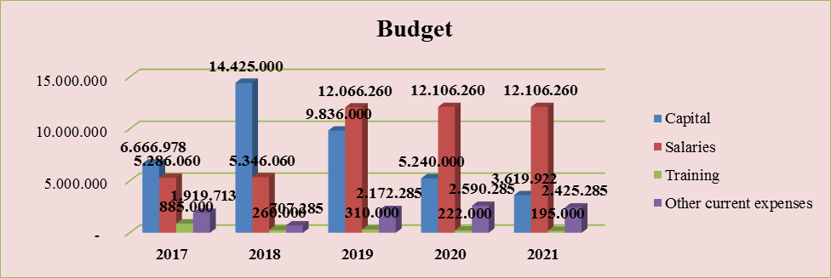

In order to avoid the financial effect (financial gap), a reserve fund has been created for 2017-2020.
Total | in EUR
Total costs for implementation of the Strategy | 98,385,653
Financial gap prior to the reserve fund | 92,285,653
Financial gap after the reserve fund | 34,822,967, specifically 35% of total costs

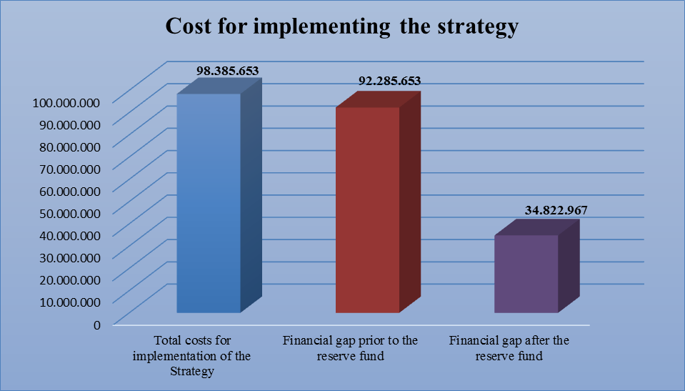

In the framework of monitoring of the implementation of action plan activities, the responsible institutions have been asked to report the amount of financial disbursement based on the performed activity. The analysis for the reported activities indicates that a total of 713,217,776 ALL has been allocated for the period january – september 2018.

PROGRESS OF IMPLEMENTATION BY OBJECTIVES

This chapter describes the progress achieved for the fulfilment of each objective of the Strategy and it presents graphically the status of implementation of the Strategy for the period january – september 2018.

Objective 1: Strengthening independence, efficiency, effectiveness and accountability of the justice system institutions.

Number of sub-activities under Objective 1
January – September 2018
Status of implementation of sub-activities of Objective 1 | Number of sub-activities | Percentage to the total of Objective 1
Implemented | 8 | 19%
Ongoing | 1 | 2%
Not implemented | 33 | 79%
Total | 42 | 100%

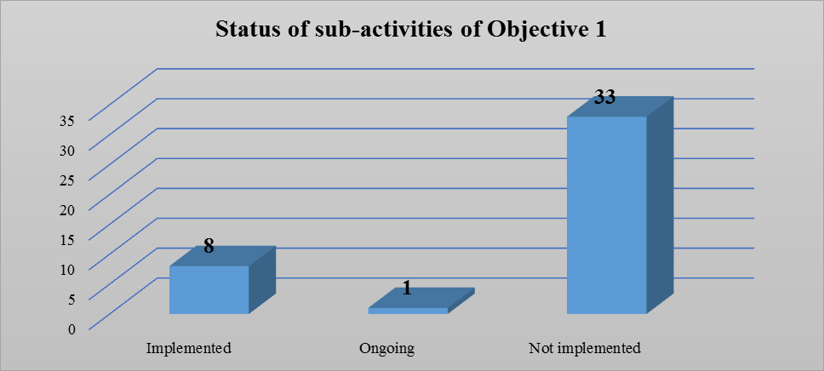

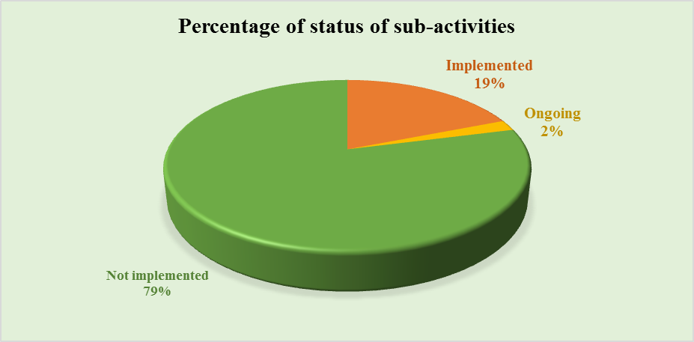
As a result from 42 sub-activities foreseen in the Action Plan of the Strategy for objective 1, 8 are implemented, 1 is still ongoing and 33 sub-activities are not implemented from the responsible institutions. The percentage to the total progress of implementation of Action Plan for this objective is at the level of 19% for the sub-activities that are implemented, the ongoing sub-activities are 2% and 79% the sub-activities that are not implemented (which will start to be implemented in the future by the responsible institutions).
It is worth mentioning that MoJ in cooperation with the Parliament and EURALIUS, OPDAT, USAID assistance has made a preliminary assessment for identification and financial costs of establishment of new bodies (HJC, HPC, JAC, HJI and anti-corruption institutions: The Special Prosecutor’s Office Against Corruption and Organised Crime/Special Court against Corruption and Organised Crime and Special Investigation Unit/National Bureau of Investigation).

Objective 2: Consolidating legal education and training as well as specialising magistrates and court personnel.

Number of sub-activities under Objective 2
January – September 2018
Status of implementation of sub-activities of Objective 2 | Number of sub-activities | Percentage to the total of Objective 2
Implemented | 8 | 62%
Ongoing | 0 | 0%
Not implemented | 5 | 38%
Total | 13 | 100 %

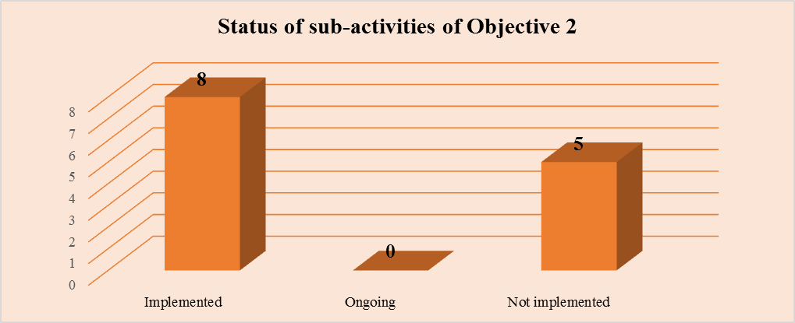
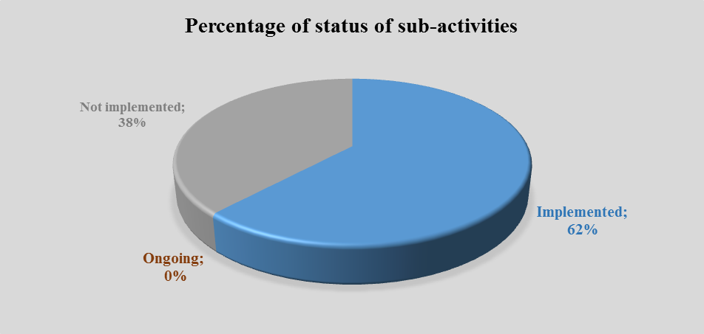
As a result from 13 sub-activities foreseen in the Action Plan of the Strategy for objective 2, 8 are implemented and 5 sub-activities are not implemented from the responsible institutions. The percentage to the total progress of implementation of Action Plan for this objective is at the level of 62% for the sub-activities that are implemented and 38% the sub-activities that are not implemented (which will start to be implemented in the future by the responsible institutions).

Objective 3: Improving the functioning of the judicial system by strengthening its efficiency, transparency and accessibility in accordance with European standards.

Number of sub-activities under Objective 3
January – September 2018
Status of implementation of sub-activities of Objective 3 | Number of sub-activities | Percentage to the total of Objective 3
Implemented | 8 | 62%
Ongoing | 2 | 15%
Not implemented | 3 | 23%
Total | 13 | 100 %

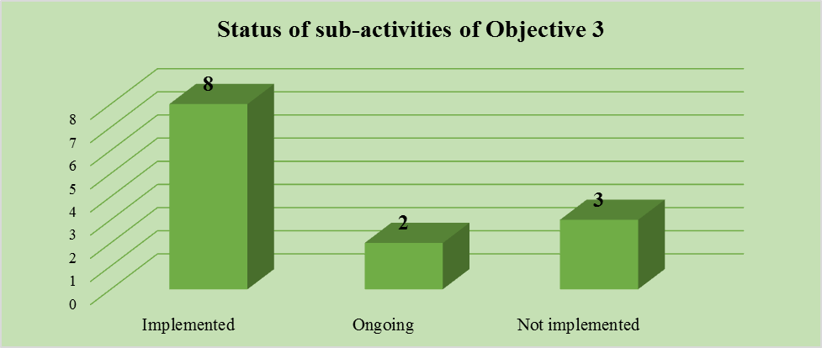
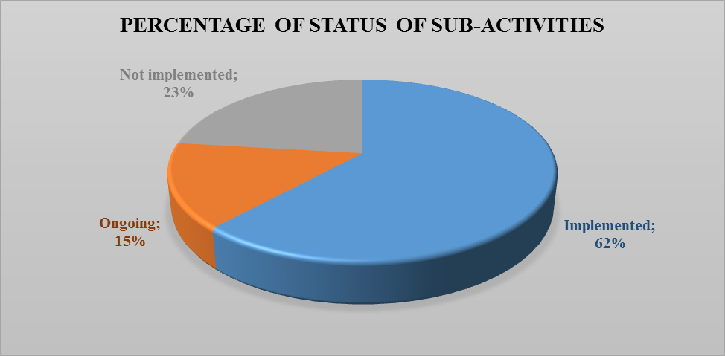
As a result from 13 sub-activities foreseen in the Action Plan of the Strategy for objective 3, 8 are implemented, 2 are still ongoing and 3 sub-activities are not implemented from the responsible institutions. The percentage to the total progress of implementation of Action Plan for this objective is at the level of 62% for the sub-activities that are implemented, the ongoing sub-activities are 15% and 23% the sub-activities that are not implemented (which will start to be implemented in the future by the responsible institutions).
Objective 4: Increasing the efficiency of the criminal justice system and anti-corruption measures through the consolidation of the mission, status and functions of criminal justice institutions.
Number of sub-activities under Objective 4
January – September 2018
Status of implementation of sub-activities of Objective 4 | Number of sub-activities | Percentage to the total of Objective 4
Implemented | 15 | 65%
Ongoing | 1 | 4%
Not implemented | 7 | 31%
Total | 23 | 100 %

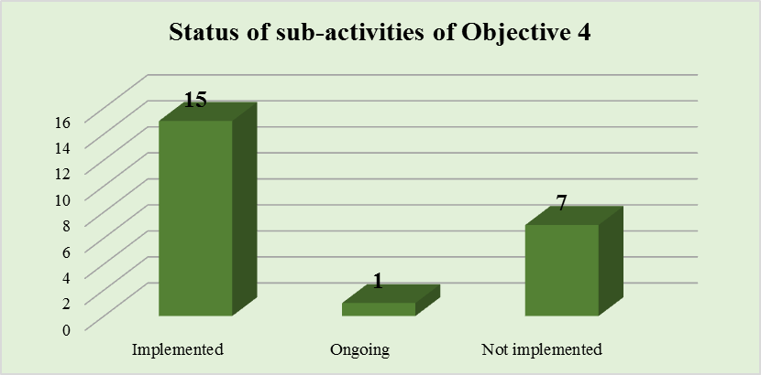
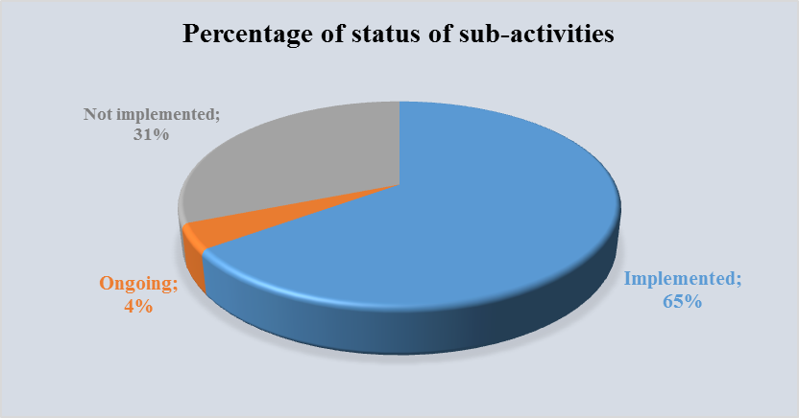
As a result from 23 sub-activities foreseen in the Action Plan of the Strategy for objective 4, 15 are implemented, 1 is still ongoing and 7 sub-activities are not implemented from the responsible institutions. The percentage to the total progress of implementation of Action Plan for this objective is at the level of 65% for the sub-activities that are implemented, the ongoing sub-activities are 4% and 31% the sub-activities that are not implemented (which will start to be implemented in the future by the responsible institutions).

Objective 5: Improving the functioning of the system by providing electronic systems procedures and facilities for development of strong international cooperation.

Number of sub-activities under Objective 5
January – September 2018
Status of implementation of sub-activities of Objective 5 | Number of sub-activities | Percentage to the total of Objective 5
Implemented | 3 | 10%
Ongoing | 9 | 30%
Not implemented | 18 | 60%
Total | 30 | 100 %

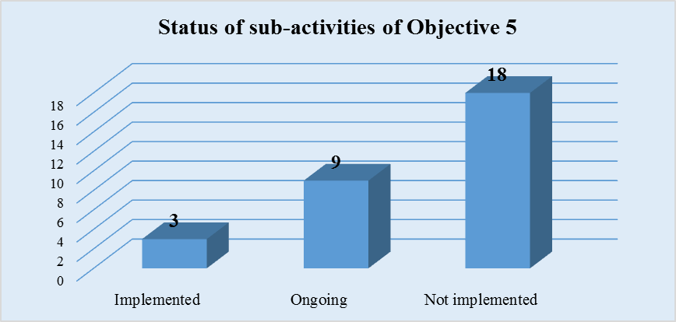
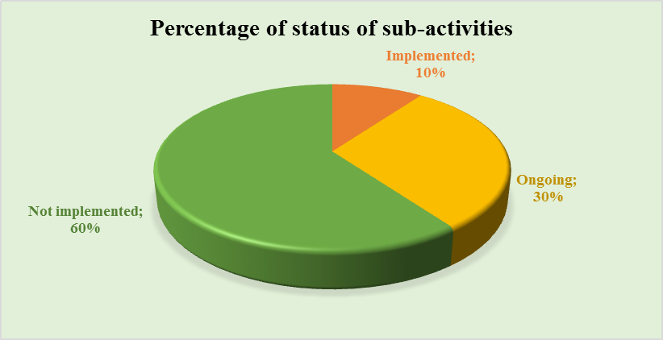
As a result from 30 sub-activities foreseen in the Action Plan of the Strategy for objective 5, 3 are implemented, 9 are still ongoing and 18 sub-activities are not implemented from the responsible institutions. The percentage to the total progress of implementation of Action Plan for this objective is at the level of 10% for the sub-activities that are implemented, the ongoing sub-activities are 30% and 60% the sub-activities that are not implemented (which will start to be implemented in the future by the responsible institutions).

Objective 6: Enhancing protection of human rights in the penitentiary system.

Number of sub-activities under Objective 6
January – September 2018
Status of implementation of sub-activities of Objective 6 | Number of sub-activities | Percentage to the total of Objective 6
Implemented | 7 | 42%
Ongoing | 5 | 29%
Not implemented | 5 | 29%
Total | 17 | 100%

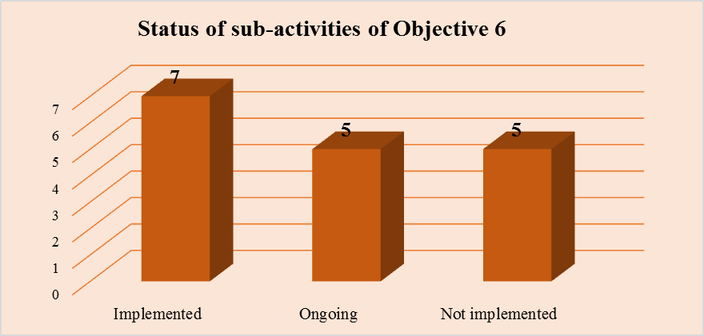
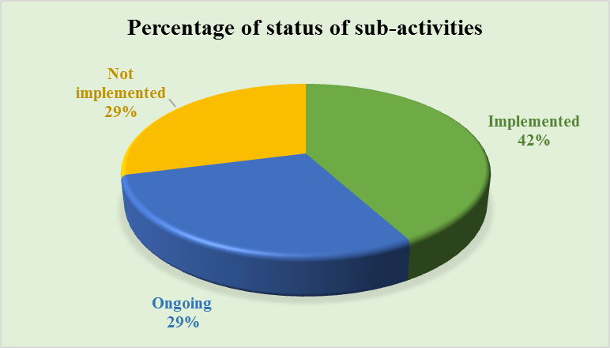
As a result from 17 sub-activities foreseen in the Action Plan of the Strategy for objective 6, 7 are implemented, 5 are still ongoing and 5 sub-activities are not implemented from the responsible institutions. The percentage to the total progress of implementation of Action Plan for this objective is at the level of 42% for the sub-activities that are implemented, the ongoing sub-activities are 29% and 29% the sub-activities that are not implemented (which will start to be implemented in the future by the responsible institutions).

Objective 7: Improving the functioning of the Ministry of Justice and its newly established or deeply changed subordinate institutions.

Number of sub-activities under Objective 7
January – September 2018
Status of implementation of sub-activities of Objective 7 | Number of sub-activities | Percentage to the total of Objective 7
Implemented | 6 | 15%
Ongoing | 9 | 22%
Not implemented | 26 | 63%
Total | 41 | 100 %

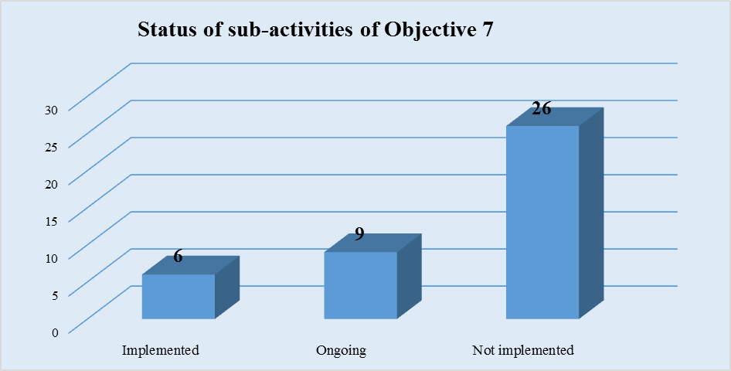
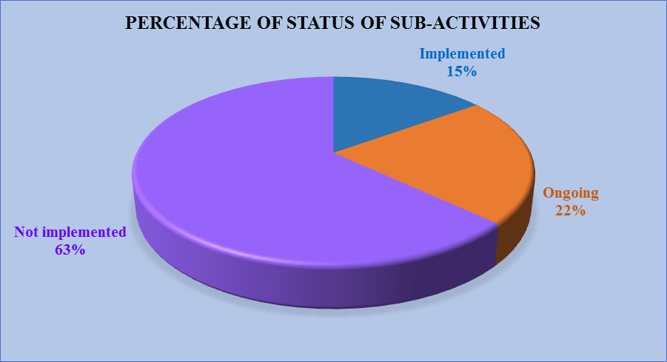
As a result from 41 sub-activities foreseen in the Action Plan of the Strategy for objective 7, 6 are implemented, 9 are still ongoing and 26 sub-activities are not implemented from the responsible institutions. The percentage to the total progress of implementation of Action Plan for this objective is at the level of 15% for the sub-activities that are implemented, the ongoing sub-activities are 22% and 63% the sub-activities that are not implemented (which will start to be implemented in the future by the responsible institutions).

Objective 8: Improving the service quality of legal professions and establishing a legal framework for arbitration.

Number of sub-activities under Objective 8
January – September 2018
Status of implementation of sub-activities of Objective 8 | Number of sub-activities | Percentage to the total of Objective 8
Implemented | 4 | 18%
Ongoing | 6 | 27%
Not implemented | 12 | 55%
Total | 22 | 100 %

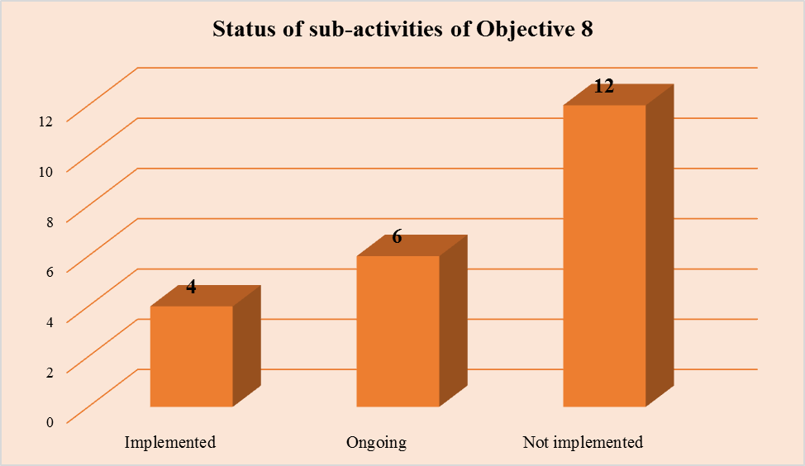
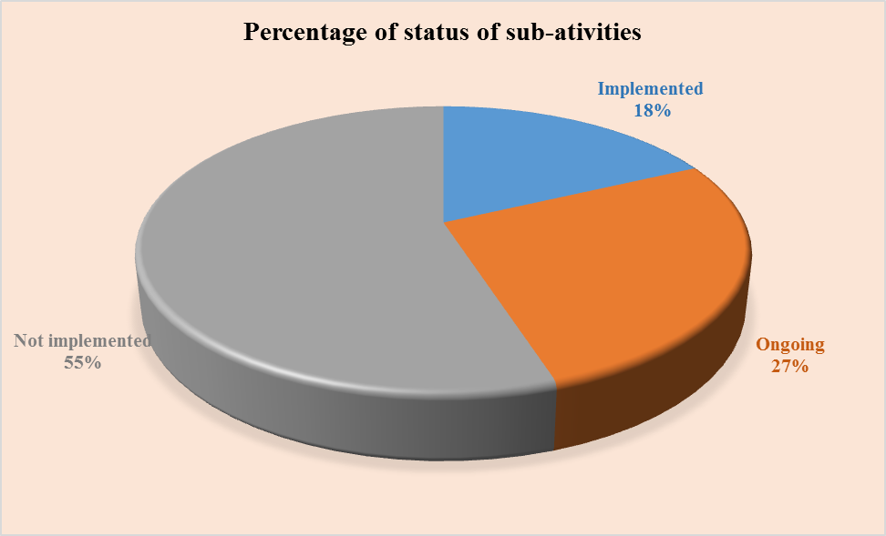
As a result from 22 sub-activities foreseen in the Action Plan of the Strategy for objective 8, 4 are implemented, 6 are still ongoing and 12 sub-activities are not implemented from the responsible institutions. The percentage to the total progress of implementation of Action Plan for this objective is at the level of 18% for the sub-activities that are implemented, the ongoing sub-activities are 27% and 55% the sub-activities that are not implemented (which will start to be implemented in the future by the responsible institutions).
- MAIN ACHIEVEMENTS DURING THE PERIOD JANUARY - SEPTEMBER 2018

The most significant achievements for the period january – september 2018, pursuant to the Action Plan 2017-2021, of the Cross-Sector Justice Strategy, are as follows:

- The School of Magistrates has drafted the curricula and has completed the relevant training regarding the fulfillment of this objective. Participants in these trainings were judges, prosecutors, inspectors, chancellors, judicial administration employees, attorneys from the State Attorney.

- Regarding the improvement of infrastructure at courts, during this period has been completed the whole reconstruction of Administrative Appeal Court of Tirana, which guarantees staff working facilities, as well as the organizations of court proceedings, quality and transparent service to the public in special environment for this purpose, etc. The court is currently exercising its activity in the reconstructed premise.

- Improvement of the judicial archive system has been completed through the implementation and operation of the central archive of courts, according to Decision no. 673, dated 22.11.2017 "On the reorganization of the National Agency for Information Society", NAIS has enabled the provision of internet service for the State Archive of the Judicial System, as well as by the decision of the Steering Council of Telecommunications Regulatory Entity No. 437 dated 21.02.2008, Electronic and Postal Communications Authority (AKEP) has enabled the domain name registration: ashsgj.gov.al.

- In the framework of improving criminal legislation in accordance with European standards, the School of Magistrates has continued the training for prosecutors and judges. Some of the topics addressed in these trainings are: "The prosecutor - court relations on the way of completing the preliminary investigations"; "Review of the final decision in the criminal process" etc.
- On 14 September was organized an activity, where 1 judge participated in training at ERA, through the School of Magistrates.
- The School of Magistrates has organized several activities for prosecutors on topics such as: Tapping as a mean to search for evidence in the criminal process; special investigative techniques; proactive investigations. In July, at the General Directorate of State Police was organized an activity about tactical interception (IMCI CATCHER), where participated judicial police officers of the tapping department at the General Prosecution Office and Tirana Prosecution Office.

- At institutional level, cooperation has been established with the projects assisting the Prosecution for the development of trainings focused mainly on the understanding of the legal amendments in the framework of justice reform. Opdat has organized trainings related to amendments of the Criminal Procedure Code and the law on prosecution in the framework of guaranteeing assistance to victims; Pameca V has organized trainings related to the preliminary session; cybercrime; anti-mafia law etc.

- The Regional Directorates of Vocational Training for the development of the vocational training process in the prisons has provided professional courses that were attended approximately by 236 detainees per month, based on the requirements of the prisoners, physical space and material basis.

- For the period January-September 2018, the working organigramme for pre-detainees and detainees was approximately 652 persons employed per month, of whom 154 are pre-detainees and 498 detainees.

- Citizens imprisoned close to the time of release are treated with specific programs for this category in order to reduce recidivism.The social staff at prisons conducts the training of this category in terms of adopting some social habits, basic skills to face the labor market, strengthening relations with relatives and the community and addressing cases without social support to relevant institutions. For the period January - September 2018 these programs were offered for about 200 detainees per month.

- For the period January-September 2018, the social staff at prisons treated with the programme for former narcotic drug users approximately 302 detainees (former narcotic drug users), of whom 64 people are treated with medication therapy by medical staff in collaboration with Aksion Plus. This program aims to stabilize the psycho-emotional state in terms of deprivation of liberty and has as a long-term objective their rehabilitation.

- The number of rehabilitation activities organized on average per month for detainees/pre-detainees at prisons is 455. The average number of detainees attending cultural and sports activities per month in the institution is 3700. At prisons, the Social Care Sectors organized on average 200 social topics and literary reviews per month, with an average attendance of 2800 detainees per month.

- The Training Sector in the GDP has developed basic training for the newly recruited staff. For the period January-September 2018, 1,428 employees were included in these trainings. A cooperation agreement has been signed to provide the most professional and productive training for the target group with the Security Academy, which has provided facilities and human resources for the realization of trainings courses. For the curriculum review, a group of experts from the General Directorate of Prisons has been established, assisted by international experts from the Council of Europe.

- 24 directors of prisons were selected through the open competition procedures, as well as the selection of staff of different levels, aiming at strengthening the professional capacities of prison staff, increasing the integrity and improving the image and services for all citizens. The selected directors were trained by the GDP Training Sector.

- Regarding the institutional and professional capacities of the Albanian Adoption Committee, training was provided for 3 employees of this institution.

- The Programme Unit of Regulatory Acts at the Prime Minister`s Office, after the process of piloting the Impact Assessment methodology (RIA), for the draft-laws stipulated by Prime Minister's Order no. 102, dated 14.06.2017, amended, in March 2018, with the support of SIGMA, it was finalized the process of updating the Methodology to bring it in a more clear and concrete format for the line ministries that will need to complement it.

- In February 2018, "RIA Network" was established, with representatives from line ministries (3 representatives from each ministry) as well as the Programme Unit of Regulatory Acts (RIA Unit) at the Prime Minister`s Office. RIA network focuses on the coordination, administration of the impact assessment process during the drafting phase of legal draft acts, in cooperation with drafting legislation units/policies.

- A manual for the use of the electronic register for public consultation was reviewed. A model for drafting reports of public consultation was drafted and delivered to the coordinators network for public consultation. The first public consultation reports were prepared from the line ministries and is in process the preparation for the consolidation report for the first semester of 2018. After the completion of public consultation network, during June 2018 two trainings were organized for all coordinators on the consulting and operating process of the electronic register for public consultation.

- In September 2018, the Assembly of the National Chamber of Mediators adopted the Curricula and Initial Training Program for persons to be licensed as mediators, the General Regulation of the Initial and Continuous Training; The Regulation on the Selection of Trainers, Regulation on the way of organizing the Examination on Mediators Licensing.

- In May 2018, the National Chamber of Mediators commenced with numerous meetings with Public and Non-public Entities, as well as with various awareness campaigns in Media, TV, web etc.

NEED TO REVIEW THE ACTION PLAN OF THE CROSS-SECTOR JUSTICE STRATEGY

The institutions have reported the need to review the Action Plan of SND, in order to convert the activities into concrete benefit for the target they are addressed to, as well as to focus on the most indispensable issues for all the justice system institutions.
This need to review is linked mainly to factors, such as:
- non-constitution, on time, of the new justice system institutions including, High Justice Inspector, High Judicial Council, High Prosecutorial Council, Justice Appointments Council, SPAK and National Bureau of Investigation.
- reviewing activities and/or indicators of its implementation in order to ensure a better compatibility with the attainment of the purpose;
- changing institutional responsibility for implementation and/or cooperating institutions, because in some cases there is an issue in defining the institution responsible for the implementation of an activity;
- changing and/or budgeting where it is missing, of the financial costs for each activity;
- managing to include the stakeholders of the justice system in the planning of activities of the Action Plan in accordance with the objectives of the Strategy, but also considering the scope of responsibility of each institution.

CONCLUSIONS

Justice reform implementation is an ongoing cross-sector process, which definition and measurement of final success indicators is complex, especially in a legal and institutional framework that is constantly changing.
Successful implementation of reforms in the justice sector, in order to ensure an effective, efficient, independent and transparent justice system in accordance with the European best practices remains the mission of this Strategy.
During the monitoring process, several problems have been identified and it has been assessed their impact on the level of implementation of the Action Plan. One of the most important elements affecting the poor implementation of activities foreseen in this Action Plan consist in:
- Non-constitution, on time, of the new justice system institutions including: High Justice Inspector, High Judicial Council, High Prosecutorial Council, Justice Appointments Council, SPAK and National Bureau of Investigation. As the institutions responsible for the implementation of most of the activities (65 sub-activities) of this Action Plan are the new justice system institutions, the lack to establish them has affected the low performance of execution of the Action Plan for this period, as well as the poor implementation of objectives defined in this strategy.
During this period, implementation and monitoring, as two interconnected processes that have guided the Ministry of Justice towards reflecting and concluding, among the most important can be mentioned:
- The need to conclude the drafting of the new Action Plan as soon as possible. This process has already started and is expected to be completed within the last 4 months of 2018.
- The financial gap of the Strategy remains still an issue of concern and it has a direct impact on the implementation of the plan. There is a need to prioritise measures and mobilise institutional mechanisms to address the financial gap and find financial resources. Moreover, interconnection with the MTBF and the projection of financial support by the State Budget must be improved. The new Action Plan must address these gaps, thus addressing even the financial reporting.
- There has been an improvement by reporting in time and with quality by a significant number of contributing institutions. There are still some problems with the reporting, mainly on financial disbursement from some of the institutions. Moreover, it is needed a higher cooperation of the Chambers to contribute to the implementation of the Action Plan of the Cross-Sector Justice Strategy.

CHALLENGES

In order to improve implementation and impact of the Action Plan, important monitoring challenges in the coming period consist in:
- ensuring a comprehensive and transparent consultation process during the reporting, monitoring and reviewing of the Action Plan with the responsible institutions and interest groups.
- increasing the level of accountability and liability by the internal structures of the responsible institutions through strengthening of the inter-institutional coordination.
- conducting the regular monitoring process, discussing the findings and approving the respective reports according to the reporting time limits foreseen in the Strategy.
- comparing information obtained from the contact points by the Finance Directorates, of respective institutions, prior to the reporting sent to the Ministry of Justice.
- Interconnection with the process of annual and mid-term budgetary planning in order to ensure the necessary financial support by the State Budget for those measures that are foreseen to be implemented by the State Budget.
- Regular informing and awareness raising of responsible institutions included in the AP on the importance of the constant work for the proper implementation of the AP and reporting on the implementation of activities.

Annex 1

Ligjet e miratuara nga paketa prej 27 ligjesh janë si më poshtë vijon:
- Law no. 35/2017 “On some addenda and amendments to law no. 7905, dated 21.3.1995 “Code of Criminal Procedure of the Republic of Albania”, amended;
- Law no. 36/2017 “On some addenda and amendments to law no. 7895, dated 27.01.1995 “Criminal Code of the Republic of Albania”, amended”;
- Law no. 37/2017 “Code of Criminal Justice for Children”;
- Law no. 32/2017 “On some amendments and addenda to law no. 10173, dated 22.10.2009 “On witness protection and justice collaborators”, amended;
- Law no. 69/2017 “On some addenda and amendments to law no. 9157, dated 04.12.2003 “On interception of electronic communication”, amended”;
- Law no. 70/2017 “On some addenda and amendments to law no. 10192, dated 3.12.2009 “On prevention and striking at organised crime, trafficking and corruption through preventive measures against assets”;
- Law no.43/2017 “On some amendments and addenda to law no. 157/2013 “On measures against financing of terrorism”;
- Law no. 44/2017 “On some addenda and amendments to law no. 9917, dated 19.5.2008 “On prevention of money laundering and financing of terrorism”, amended;
- Law no. 42/2017 “On some amendments and addenda to law “On declaration and audit of assets, financial obligations of the elected persons and some public employees”, amended;
- Law no. 38/2017 “On some addenda and amendments to law no. 8116, dated 29.3.1996, “Code of Civil Procedure of the Republic of Albania”, amended;
- Law no. 40/2017 “On some amendments to the law no. 8678, dated 14.05.2001, “On organisation and functioning of the Ministry of Justice”, amended;
- Law no. 39/2017 “On some addenda and amendments to law no. 49/2012 "On organisation and functioning of Administrative Courts and adjudication of administrative disputes” amended”;
- Law no. 41/2017 “On some addenda and amendments to law no. 152/2013, “On civil servant”, amended”;
- Law no. 111/2017 “On state guaranteed legal aid”;
- Law no. 98/2017 “On court fees in the Republic of Albania”.
- Law no. 26/2018 “On some addenda and amendments to the law no. 10385, dated 24.2.2011 “On mediation in dispute resolution”;
- Law no. 55/2018 “On the profession of the lawyer in the Republic of Albania”.

Draft-laws which are still pending include:
- Draft-law “On organisation and functioning of Judicial Police”;
- Draft-law “On some amendments and addenda to law no. 8331, dated 21.4.1998 “On execution of criminal sentences”, amended;
- Draft-law “On strategy of legal education in the Republic of Albania”;
- Draft-law “On some addenda and amendments to law no. 7829, dated 01.06.1994 “On notary”, amended;
- Draft-law “On some amendments and addenda to law no. 10031, dated 11.12.2008, “On private judicial enforcement service”;
- Draft-law "On some addenda to law no. 9936, dated 26.6.2008, “On management of budgetary system in the Republic of Albania".

Draft-laws which are withdrawn include:
- Draft-law “On some addenda and amendments to law no. 8328, dated 16.4.1998 “On the rights and treatment of convicts and detainees” amended;
- Draft-law “On the President of the Republic of Albania”;
- Draft-law “On some addenda and amendments to law no. 10018 dated 13.11.2008 “On state Advocate's Office”.
- Draft-law “On the state exam for the profession of the jurist”.

Sub-activity 3.01.c “Domain name registration” for which Parlament is the responsible institution, as foreseen in AC of SND, is not counted/included in analyses because this sub-activity does not respond to the needs of the institution and therefore the “responsible institution” should be reviewed.
Additional information on the package of 27 laws is included in the annex 1 to this report.
http://www.gjykataelarte.gov.al/web/ligj_nr_115_2016_per_organet_e_qeverisjes_se_sistemit_te_drejtesise_1726.pdf
https://www.parlament.al/wp-content/uploads/2016/10/ligj-nr-95-dt-6-10-2016.pdf
http://www.qbz.gov.al/botime/fletore_zyrtare/2016/PDF-2016/209-2016.pdf
http://www.avokatipopullit.gov.al/sites/default/files/VETINGU/ligj-nr-84-dt-30-8-2016.pdf
The budget that is the same for some of the sub-activities of General Directorate of Prisons and for a part of activities of the School of Magistrates is calculated in the total cost of the SND only once, as it is the same article which is repeated in some sub-activities.
The Action Plan and progress for each objective is reflected in Annex 2 of the Monitoring Report.

