MONITORING REPORT

JANUARY – JUNE 2019

JUVENILE JUSTICE STRATEGY

www.drejtesia.gov.al

Table of Contents

I. EXECUTIVE SUMMARY ON MONITORING THE NATIONAL JUVENILE JUSTICE STRATEGY 2018 – 2021 AND ACTION PLAN FOR PERIOD JANUARY – JUNE 2019. 4
1. Introduction 4
2. Progress in legislation 5
3. Cooperation agreements between the Ministry of Justice and the municipalities in the Republic of Albania. 6
4. Infrastructure framework for juveniles in conflict with the law. 7
II. MONITORING METHODOLOGY 7
III. IMPLEMENTATION PROGRESS BY OBJECTIVES 8
Objective 1: Ensure the access of justice to juveniles. 8
Objective 2: Ensure a correct legal proccess for juveniles 9
Objective 3: Preventing juveniles’ re-involvement in crime. 10
Objective 4: Re-socialization, reintegration and rehabilitation of juveniles in contact with or in conflict with the law. 12
Objective 5: Strengthen the cooperation of justice system institutions for juveniles. 13
IV. MAIN ACHIEVEMENTS DURING JANUARY - JUNE 2019. 15
V. IMPLEMENTATION OF INTERNATIONAL PROJECTS AND PROGRAMS IN THE FIELD OF CRIMINAL JUSTICE FOR JUVENILES 18
VI. CONCLUSIONS AND CHALLENGES 20
APPENDIX 1 21
APPENDIX 2 22

Acronyms

SARPC State Agency for the Rights and Protection of the Child
SA Security Academy (Police Academy)
DPA Department of Public Administration
GDP General Department of Prisons
GDSP General Department of the State Police
GDPS General Department of Probation Service
CC Council of the Court
HCJ High Council of Justice
HCP High Council of Prosecution
IPS Government’s Integrated Planning System
CRIPPD Commissioner for the Rights to Information and Protection of Personal Data
CPD Commissioner for Protection from Discrimination
CoM Council of Ministers
AAC Albanian Adoption Committee
MoJ Ministry of Justice
MoI Ministry of Interior
MoHSP Ministry of Health and Social Protection
MoESY Ministry of Education, Sports and Youth
MoFE Ministry of Finance and Economy
MTBP Mid-Term Budgetary Programme
GPO General Prosecutor’s Office
RP Republic of Albania
SoM School of Magistrates
OoP Order of Psychologist
DCM Decision of the Council of Ministers

EXECUTIVE SUMMARY ON MONITORING THE NATIONAL JUVENILE JUSTICE STRATEGY 2018 – 2021 AND ACTION PLAN FOR JANUARY – JUNE 2019.

Introduction

As part of the justice reform, Law no. 37/2017, dated 30.03.2017 “Justice Criminal Code for Juveniles” and Law no. 18/2017 “On the rights and protection of children” that regulate the organization and functioning of institutions for the treatment and protection of children's rights are approved.

On January 1, 2018, Law no. 37/2017, dated 30.03.2017 “Justice Criminal Code for Juveniles”, which contains special legal norms related to juveniles’criminal responsibility, procedural rules regarding investigation, prosecution, litigation, execution of criminal sentminorence, rehabilitation or any other measure involving a juvenile in conflict with the law, a juvenile victim and / or witness of the offense, as well as rules for young people between the ages of 18 and 21. This law is a novelty and develops the standards of Albanian legislation in protecting the rights of children as a whole and minors in conflict with the law in particular. The Code is a special law because of its content as it encompasses all the provisions referring to a juvenilemino in the Criminal Code, the Criminal Procedure Code, the Law "On the Rights and Treatment of Prisoners and Detainees", as well as laws other references to the juvenile criminal justice system. This Code provides for the approximation of Albanian legislation with Directive 2011/93/EU dated 13.12.2011, in addition to compliance with international and regional standards.
In full implementation of this Code, a number of measures are envisaged in the Juvenile Justice Strategy Action Plan

The National Juvenile Justice Strategy 2018 – 2021 and its Action Plan is approved by the Council of the Ministers, Decision no.541, date 19.09.2018.

The vision of the strategy is to improve justice for children guaranteeing a child-friendly justice that protects their best interests.
The purpose of the Juvenile Justice Strategy (2018-2021) is to promote and effectively protect the rights and needs of: children in conflict with the law, children victims or witnesses of crime, children under age of criminal responsibility, whether in criminal judicial proceedings or alternatives thereof, as well as children participating in administrative or civil court proceedings, through the implementation of national and international standards of child rights. The strategy has an interdisciplinary approach, it ensures alignment with all other existing national documents, and contains concrete activities.

The strategy has five objectives of the highest level, listed as below:

- Guarantee juvenile’s access to justice.
- Ensure fair trial for children.
- Prevent re-involvement of children in delinquency.
- Re-socialisation, reintegration and rehabilitation of juveniles in conflict with the law.
- Strengthening collaboration between the justice authorities (institutions) for juvenile’s system

The Strategic Objectives will be addressed through well-thought and programmed policies, with a view to ensure a positive and sustainable impact in the respect, promotion and protection of the rights of the children interacting with the justice system authorities.

This report is designed to implement the Action Plan 2018 – 2021 of the Juvenile Justice Strategy and to represent the first monitoring report for 2019. The report shows progress from January 1, 2019 to June 30, 2019. In order to monitor the achievements, progress/challenges to complete the strategy’s objectives, information has been provided from every relevant institution related to the implementation of Juvenile Justice Strategy.

The Action Plan consist from the five objectives mentioned above, and contains 25 sub-activities. In order to monitor the implementation of the taken measures, according to the completion of the strategic objectives, the monitoring process has been performed in an objective level. The level evaluation and the status of the implementation of the measures/sub-activities of the Strategy is based on the information given from every responsible unit. Ministry of Justice has proceeded with the evaluation of the information during July – August 2019.

Progress in legislation
The protection and guarantee of the children rights is one of the key priorities of the Ministry of Justice, and the Program of the Albanian Government under the great objective “The implementation of reforming the justice systes for children in conflict with law, by forcing the restorative justice system and efective procedural defense”.

The Ministry of Justice, based on the domestic and international legal framework regulating the field of children's rights, considers that the child best interest is an important principle, which must be applied first in criminal law, but also in administrative and ciliv law.

The protection of children's rights by guaranteeing the provision of services in the juridicial system has been one of the basic adjustments of the latest legal package on the regulation of the justice system in the context of justice reform. In particular, children in the criminal justice system constitute of a vulnerable category and guaranteeing prompt, effective and qualitative legal procedures has been the most important aim of the reform of the criminal justice system, concretized by the adoption of the Justice criminal Code for Children and the Law on the Rights and Protection of Children, as well as a number of other material and procedural norms. Six Decisions Council of Ministers, as well as orders, instructions, a project decision are also approved guaranteeing the protection of children's rights in this regard.

Cooperation agreements between the Ministry of Justice and the municipalities in the Republic of Albania.
Another much needed commitment for the effective implementation of the Juvenile Justice Strategy and Action Plan 2018-2021 is the strengthening of the Probation Service's cooperation with structures at the local level, with the aim of treating juveniles with the alternative measure of avoidance at multidisciplinary social centers. Inter-institutional cooperation between the links of the justice system and local government structures is essential in completing the institutional framework for the implementation of the juvenile justice legislation in practice. For this purpose during 2018, 7 cooperation agreements were signed with 11 other municipalities from January to June 2019.
The multidisciplinary centers near the municipalities with which the agreements were signed are operational and open to any possible referral of cases by the Prosecution and the Court. Currently, multidisciplinary centers are setting up Intersectoral Technical Groups (ITGs), attended by Child Protection Workers (CPWs), psychologists, social workers, lawyers, doctors, and other field professionals, as the needs assessment of the minors are made. In cases where the prosecution provides avoidance measures and the juvenile is to be supervised by the Probation Service, the relevant specialist participates in the ITG and handles the case as appropriate. The types of services provided to juveniles in conflict with the law are varied, including individual and family counseling, social, educational, outreach, etc., and any other assistance that ITG assesses for the minor’s needs.

The object of signing of these agreements between the Parties is to establish cooperation between the two institutions for the realization and supervision of alternative measures to avoid prosecution and sentence of juveniles in conflict with the Law.
Signing of the Agreement The Parties agree to cooperate with a view of implementing measures of avoidance for juveniles in conflict with the law through:
i) providing full range of social services for juveniles at Social Centers depending on the Municipality;
ii) organization and participation of the staff of the Child Protection and Probation Service in joint trainings in order to strengthen the professional capacity of the support services structures in this process;
iii) facilitating the provision of assistance and support to juveniles in conflict with the law and his or her family, when required by them;
iv) promoting the model of child-friendly justice in conflict with the law by organizing awareness-raising, educational, entertainment and other activities tailored to the needs of the juveniles.

It is worth noting that the Ministry of Justice has concluded cooperation agreements on juvenile justice restoration programs with all NGOs that aim at modeling reintegration services for children in conflict with the law as well as strengthening and capacity building of the bodies responsible for implementing this model. The model of reintegration services will be developed in cooperation with the Ministry of Health and Social Protection, the Ministry of Justice, the Municipality of Tirana, the General Directorate of Probation Service, the Vocational Training Centers etc.

Infrastructure framework for juveniles in conflict with the law.

Establishment of new institutions for the implementation of the Juvenile’ Criminal Code, as a condition for completing the necessary infrastructure to implement the by-laws, alternative sentencing measures and reintegration of juveniles into society, is one of the most important links to achieve. To this end, the Ministry of Justice is engaged in the establishment of new institutions.
The Minors and Juvenile Crime Prevention Center, an institution conceived as a subordinate mechanism by the Ministry of Justice, will develop a preventive program and will oversee a juvenile for a six-month period following the end of sentencing. This facility is planned with an initial capacity of 16 employees. Full practice has been prepared for the approval of the structure, staffing and job descriptions for the purpose of consulting them with the Department of Public Administration and the Ministry of Finance and Economy;
Juvenile Education and Rehabilitation Institution, an institution conceived as an institution to which rehabilitation and reintegration programs for juveniles who have been convicted by the court will be implemented with the sentence of restriction of liberty. The facility is planned for this institution with an initial capacity of 34 employees who will handle about 20 minors. Currently, the geographic settlement options (Tirana, Durres or Kurbin) and infrastructure opportunities for the establishment of this institution are currently being evaluated.
The establishment and functioning of these two institutions will serve the treatment of juveniles in accordance with the highest standards of protection of their rights, aiming at the education, rehabilitation and reintegration of juveniles in conflict with the law. The purpose of these two institutions is for juveniles in conflict with the law to be treated without isolation through appropriate programs for education, rehabilitation and reintegration into the community and society and to avoid re-engaging them in crime and reducing recidivism. . For these two institutions, the fund is foreseen to invest in value corresponding to the budgetary years 2019/2020/2021/2022.

Creation and operation of the Electronic Juvenile Criminal Justice Data System is another important challenge, which enables tracking of juvenile cases step by step and after each phase, as well as generating timely statistical data. The Ministry of Justice in cooperation with NAIS is working on the modalities of setting up this system, taking into account the model already built by UNICEF for this purpose.

MONITORING METHODOLOGY

The Sector for Monitoring, Implementation of Priorities and Statistics, within the Department of Justice Policy and Strategies has been set up at the Ministry of Justice, which is the structure responsible for the monitoring process and for drafting the Strategic Monitoring Reports, pursuant to the Order Prime Minister Nr. 166, dt. 5.10.2017 “On the approval of the structure and organization of the Ministry of Justice”.
Monitoring, Implementation of Priorities and Statistics Sector coordinates with all responsible institutions, and then proceeds with the drafting of the monitoring report. This report covers the period from 1 January to 30 June 2019 and is drawn up on the basis of input from all institutions included in the SDM Action Plan. The goal is to have information on achievements, progress and challenges towards meeting the objectives of the strategy.
Each institution has reported on the level of implementation of each policy and activity, the allocated budget, the problems encountered and the evaluation of the progress of the strategy as a whole. In order to monitor the implementation of the undertaken commitments regarding the implementation of the sub-activities, the monitoring process was carried out at the objective level. The verification of reported data was partially performed online, for those measures which the contact points had reported to ensure their accuracy. Statistical treatment was performed by coding responses based on the reports collected.
The Ministry of Justice, in support of the monitoring process, sends the document to be consukted by the reporting institutions, civil society, and publishes the draft on the official website of the Ministry of Justice, which also includes an email address for receiving comments. At the end of the consultation process, the Ministry of Justice reflects relevant comments/suggestions on the draft monitoring report before being approved by the Institutional Monitoring Mechanism. Once approved, the Final Report is published on the official website of the Ministry of Justice.

IMPLEMENTATION PROGRESS BY OBJECTIVES

This chapter describes the progress achieved in meeting each of the objectives of the Strategy and graphically illustrates the implementation status of the Strategy for the period January - June 2019.

Objective 1: Ensure the access of justice to juveniles.
The strategy predicts that access to justice will be guaranteed by delivering concrete measurable results by: i) the number of structures and professionals providing legal assistance; ii) the number of premises reconstructed to suit the needs of juveniles and iii) the number of awareness-raising activities for juvenile’ justice. This aspect relates to juveniles’ capacity to access juveniles justice services and includes raising awareness and the provision of free legal aid, the concrete activities of which will be covered in the coming chapter.

Number of measures under implementation according to Objective 1
January – June 2019
Implementation status of measures under Objective 1 | Number of measures | Percentage to the total of Objective 1
Implemented | 2 | 50%
Ongoing | 2 | 50%
Not implemented | 0 | 0%
Total | 4 | 100%

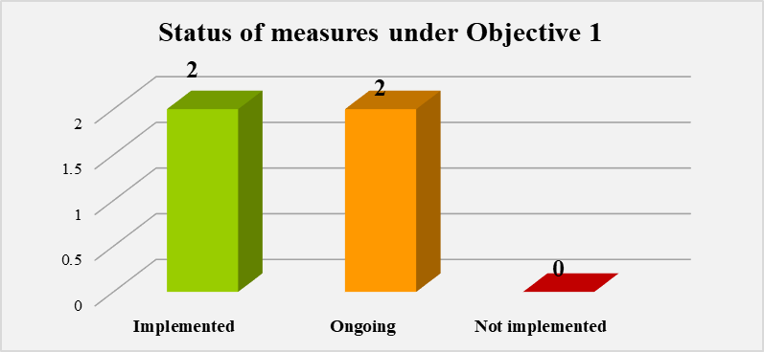
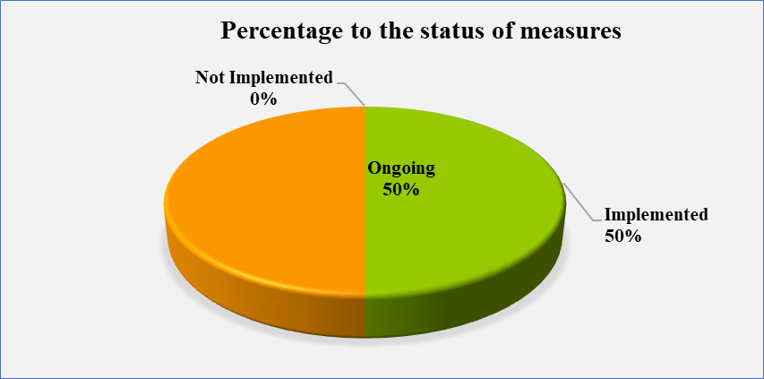
It results that from 4 measures foreseen in the Action Plan of the Strategy for objective 1, 2 of them are implemented, 2 are still ongoing. The percentage against the total progress of implementation of the Action Plan for this objective is 50% for the implemented measures, 50% for ongoing measures.

Objective 2: Ensure a correct legal proccess for juveniles.
Having in consideration the country's obligation to respect and guarantee the rights provided by the European Convention on Human Rights, the strategy has planned concrete activities aimed at guaranteeing this right for juveniles involved in trials. The focus of the strategy is to ensure a fair trial within a reasonable time, improve the legal framework that rates children's rights, and support juveniles in any process by trained and specialized professionals. The Strategy foresees that this objective will be guaranteed by giving concrete results regarding: i) the number of specialized sections for juveniles in courts and prosecutors; ii) the number of professionals trained in juveniles’ justice issues; iii) the number of institutions that record data in the Integrated Juvenile Criminal Justice Data System and iv) the number of laws / bylaws adopted in the field of juveniles’ justice.

Number of measures under implementation according to Objective 2
January – June 2019
Implementation status of measures under Objective 2 | Number of measures | Percentage to the total of Objective 2
Implemented | 1 | 14%
Ongoing | 5 | 72%
Not implemented | 1 | 14%
Total | 7 | 100%

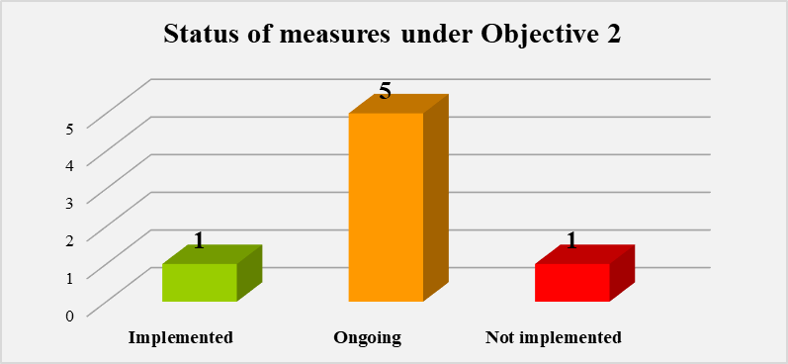
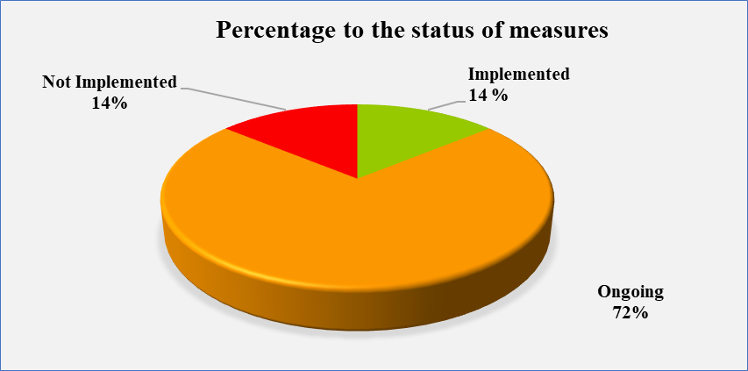

It results that from 7 measures foreseen in the Action Plan of the Strategy for objective 2, 1 of them is implemented, 5 are still ongoing, as well as 1 measure is not implemented by the responsible institution. The percentage against the total progress of implementation of the Action Plan for this objective is 14% for the implemented measure, 72% for ongoing measures, as well as 14% for measures that will start to be carried out in the future by the responsible institutions.

Objective 3: Preventing juveniles re-involvement in crime.
To achieve this objective it is planned to analyze the risk factors and precautionary measures. Given that this is the first Juvenile Justice Strategy, the objective focuses in particular on the establishment and operation of the Minors and Juveniles Crime Prevention Center as well as programs preventing minors re-inclusion in criminal acts (recidivism), which will focus on support for children and families, especially children under the age of criminal responsibility and at risk or vulnerable groups. Crime prevention is the best solution for children, their families, communities and society at large.

Number of measures under implementation according to Objective 3
January – June 2019
Implementation status of measures under Objective 3 | Number of measures | Percentage to the total of Objective 3
Implemented | 0 | 0%
Ongoing | 2 | 50%
Not implemented | 2 | 50%
Total | 4 | 100%

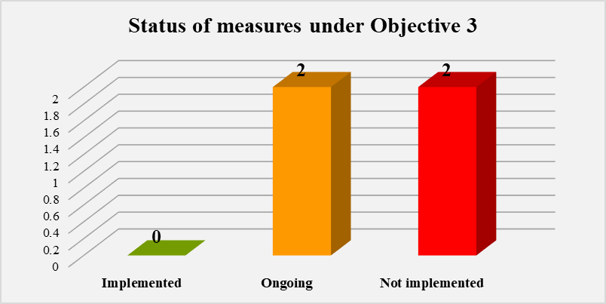
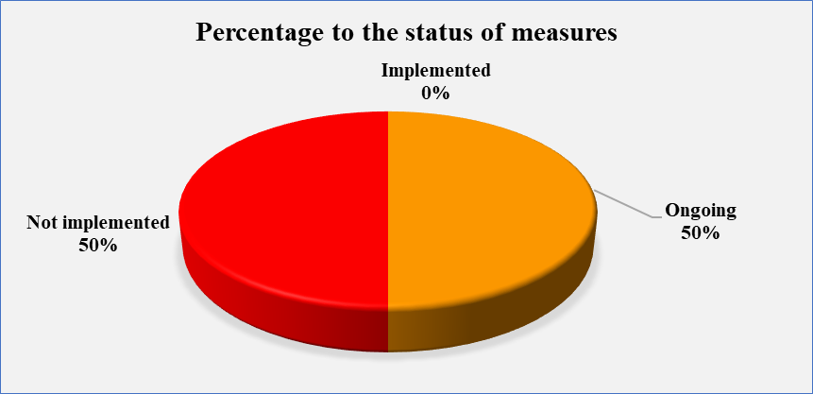

It results that from 4 measures foreseen in the Action Plan of the Strategy for objective 3, 2 of them are still ongoing and 2 measures not implemented by the responsible institutions. The percentage against the total progress of implementation of the Action Plan for this objective is 50% for ongoing measures and 50% for measures that will start to be carried out in the future by the responsible institutions.

Objective 4: Re-socialization, reintegration and rehabilitation of juveniles in contact with or in conflict with the law.

The strategy aims at the reintegration and social inclusion of juvenile offenders and their effective inclusion in the community. The purpose of this objective is to rehabilitate juveniles, encourage and develop, in terms of juvenile responsibility, a sense of respect for the rights of others, foster and enable healthy physical, mental, spiritual, moral and social development of the juvenile and to prepare him to return to society.

The strategy envisages to measure the achievement of this objective through: i) the number of children and families involved in reintegration programs; (ii) the number of children sentenced to imprisonment and alternative measures and the number of children to whom alternative measures of avoidance of prosecution have been applied.

Number of measures under implementation according to Objective 4
January – June 2019
Implementation status of measures under Objective 4 | Number of measures | Percentage to the total of Objective 4
Implemented | 0 | 0%
Ongoing | 7 | 88%
Not implemented | 1 | 12%
Total | 8 | 100%

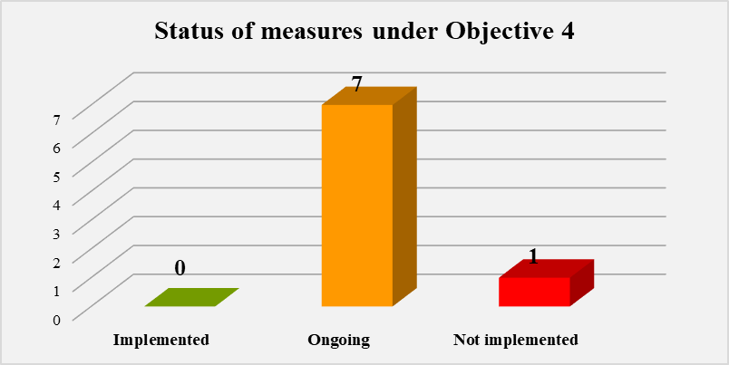

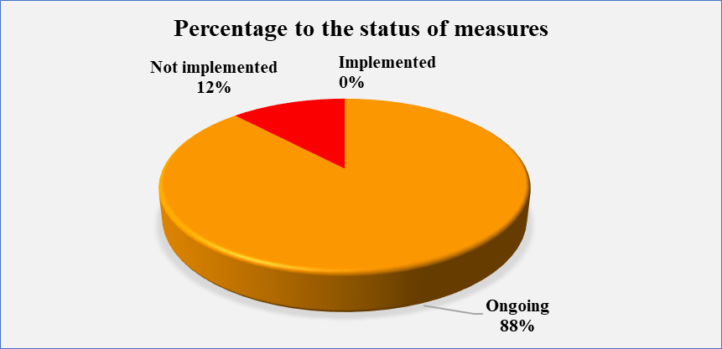

It results that from 8 measures foreseen in the Action Plan of the Strategy for objective 4, 7 of them are 7 still ongoing, as well as 1 measure is not implemented by the responsible institution. The percentage against the total progress of implementation of the Action Plan for this objective is 88% for ongoing measures and 12% for measures that will start to be carried out in the future by the responsible institutions.

Objective 5: Strengthen the cooperation of justice system institutions for juveniles.
It is considered that the essential condition for the proper and effective implementation of children's rights and guarantees is the cooperation, interaction and coordination of institutions and authorities at central and local level involved in the administration of juvenile justice. Consequently, the strategy envisages the establishment and operation of an inter-institutional network at the central level and a functioning community of practitioners at the local level.

Number of measures under implementation according to Objective 5
January – June 2019
Implementation status of measures under Objective 5 | Number of measures | Percentage to the total of Objective 5
Implemented | 0 | 0%
Ongoing | 1 | 50%
Not implemented | 1 | 50%
Total | 2 | 100%

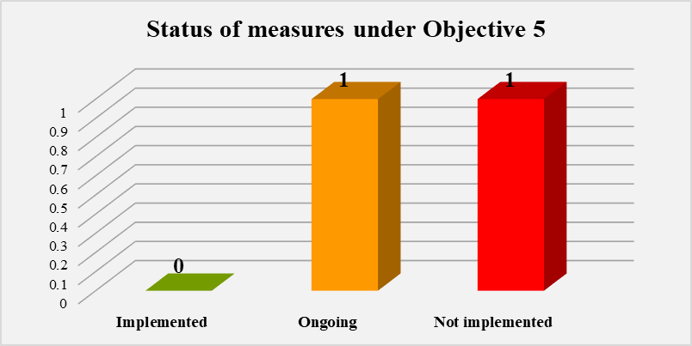

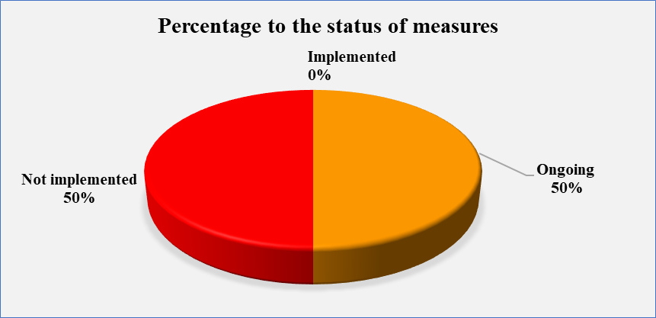

It results that from 2 measures foreseen in the Action Plan of the Strategy for objective 5, 1 of them is still ongoing, as well as 1 measures is not implemented by the responsible institutions. The percentage against the total progress of implementation of the Action Plan for this objective is 50% for ongoing measures and 50% for measures that will start to be carried out in the future by the responsible institutions.

Implementation Status of Measures according to Objectives

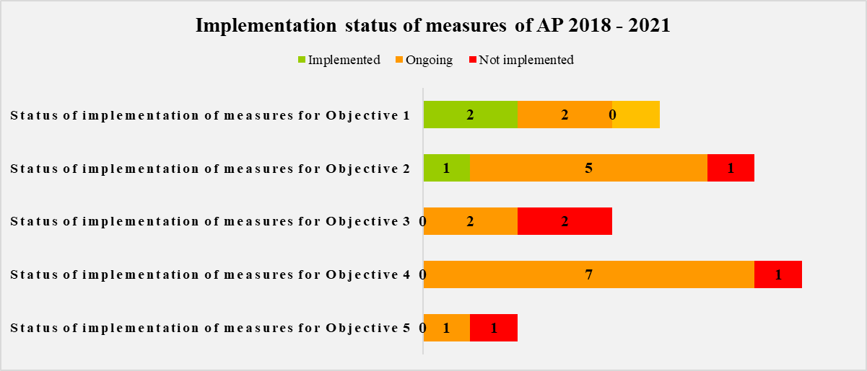

Total Progress of Measures of AP
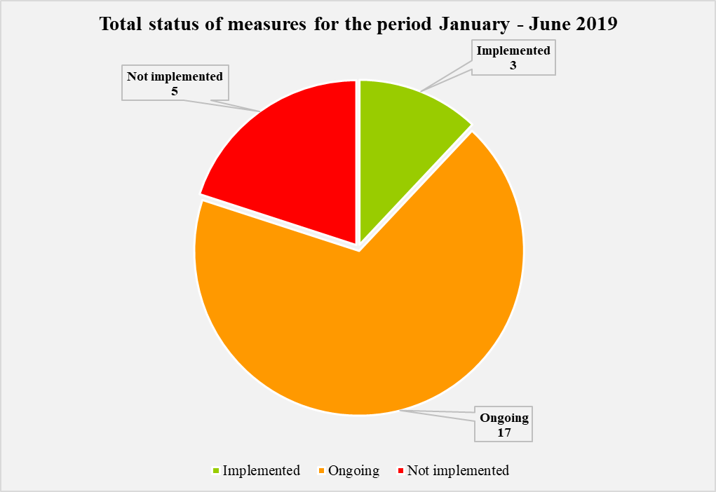

For the period January – June 2019, out of 25 measures foreseen in the Action Plan, there are implemented 3 of them, 17 are ongoing, 5 measures are not implemented by responsible institutions. The percentage against total progress of implementation of Action Plan is at 12% on measures that are implemented, 68% for ongoing measures, 20% on measures that will be carried out in the future by responsible institutions. From the analysis on reported measures it results that during January – June 2019 there have been spent from the donors budget a total of roughly 23.366.830 ALL.

IV. MAIN ACHIEVEMENTS DURING JANUARY - JUNE 2019.
- In implementation to the Juvenile Criminal Code, 5 bylaws were adopted by the Council of Ministers in the period January - June 2019 and 1 act was adopted in 2018 completing the package of 6 legal acts. The package of orders and instructions of the Minister of Justice was also approved, which has been finalized and have already been implemented by law enforcement institutions.
- Concerning the effective implementation of the institutional framework which is a much needed mechanism for engaging all actors in the criminal justice system for minors and enables the strengthening of cooperation with the Probation Service structures at the local level. The Ministry of Justice from January to June 2019 has signed 11 more cooperation agreements and 7 agreements in 2018 leading to a total of 18 cooperation agreements in the respective municipalities such as: Tirana, Korça, Durrës, Kukës, Puka, Berat, Elbasan, Lushnja, Kavaja, Kurbin, Fier, Vlora, Gjirokastra, Pogradec Kruje, Tropoja, Diber, Shkodra. Inter-institutional cooperation between the links of the justice system and local government structures is essential in completing the institutional framework for the implementation of the juvenile justice legislation in practice.
- As part of the implementation of the Juvenile Criminal Code, the Probation Service has issued 144 alternative sentences for the period January - June 2019.
- The Ministry of Justice in implementation of the Specific Objective “Providing legal assistance to juvenile beneficiaries to ensure that this service is prompt, professional and effective” has approved the order no. 225, dated 25/03/2019 of the Minister of Justice, by which the self-declaration forms were approved.
- Regarding the Specific Objective for “Creating Infrastructure Conditions Appropriate to the Needs of Minors” the State Police has drafted the Draft Standard Operating Procedures for the “Juvenile Interview Unit, technical standards and procedures for using these facilities”, which by Order No. 715, dated 05.06.2019, have been approved by the General Director of State Police. This activity was carried out in cooperation with the representative of the Swedish Police Authority, in the framework of the three-year Program 2017-2020, “Strengthening the capacities of Albanian law enforcement agencies to meet human rights standards in juvenile justice - an approach inclusive of the justice chain. ” The premises where the “Juvenile Interview Unit” will be built/adapted have been identified, and work has begun on preparing projects for the adaptation / construction of facilities in two police structures, namely;
• In DVP - Tirana, at the premises of Police Station No.3.
• In DVP - Durres, in the premises near this directory
- Regarding the Integrated Juvenile Criminal Justice Data System, the creation of which is a legal obligation under Article 136 of the Juvenile Criminal Code, which determines: criminal cases involving juveniles in conflict with criminal law, juvenile victims and witnesses of criminal offenses, the Integrated criminal Justice Data System for Juveniles is established, with the decision of the Council of Ministers, DCM no. 149 dated 20.03.2019 "On the establishment, organization, functioning, characteristics of use and access, primary and secondary data and information provider of the integrated juvenile justice data system". In DCM no. 149, dated 20.03.2019, point 4 provides that: “The establishment, operation and administration of the Integrated Juvenile Justice Data System is done in a “Webbased” format, and further states that: The Integrated Juvenile Justice criminal Justice Database, as a state database, is hosted on the servers of the National Information Society Agency (“NAIS”), pursuant to point 5 of the aforementioned DCM. The Ministry of Justice has set up a working group to collaborate with NAIS and UNICEF on the establishment of the Integrated Juvenile criminal Justice Data System, which includes the dissemination and updating of juvenile criminal justice data and for the purpose of collecting real-time data, improving access to justice and the good administration of the juvenile justice system, coordinating inter-institutional efforts, unifying and computerizing data to assist in the analysis and improvement of criminal justice policies for minors.
- With the approval of the Council of Ministers of DCM no. 314, dated 15.05.2019, the Center for the Prevention of Minors and Juvenile Crime is an institution conceived as a mechanism subordinate to the Ministry of Justice, which will develop a preventive program and supervise a juvenile for a 6-month period after completion of sentence. This institution is planned with an initial capacity of 16 employees.
- In implementation of the General Prosecutor's Office's work plan for 2019, experts of the working group representing specialized prosecutors on juvenile justice issues have drafted a Letter of Rights for the juvenile defendant, juvenile victim and are working on developing an information manual.
- School of Magistrates has held on January 23-24, 2019; February 25-26, 2019; and April 11-12, 2019 trainings on “Criminal justice for juveniles”. International Standards on the Principles of Juvenile Friendly Justice and Innovation in Albanian Legislation (Criminal Procedure Code and Juvenile Justice Code); Protecting the best interest of the child; Juvenile’s procedural position in and during criminal proceedings under the Juvenile Justice Code; Avoidance of prosecution of a juvenile in conflict with the law. Procedural rights of juveniles in conflict with the law ”. This training was attended by 20 magistrates of the prosecutor's profile, 16 of which are practicing law in the courts of first instance and 4 have completed the School of Magistrates (but have not yet been appointed). This training was attended by 2 legal advisers in the General Prosecutor's Office.
- The Ombudsperson Institution and specifically the Section for the Protection and Promotion of the Rights of the Child, in implementation of its Strategy and Action Plan 2019-2022, for the protection and promotion of the rights of the child, has set out among the strategic objectives, even that of promoting a child-friendly justice. Specifically, promoting the rights and protection of children in conflict with the law, victims or witnesses. The activities organized by the Ombudsperson Institution were attended by international and national organizations operating in the field of protection of children's rights, public administration institutions at central and local level and children / youth as part of the "voice 16+".
- The Ministry of Education organized an activity on the topic "Alternative Restorative Approaches for juveniles and Youth in Contact and Conflict with the Law". This activity and organization as part of the program "Activating civil society in modeling restoration practices for services and youth in contact with the law". Six awareness sessions were organized in high schools such as Petro Nini, Partizani, Myslym Keta, Qemal Stafa Raqi Qirinxhi, Siri Shaplo in January-February 2019. This activity was funded by the European Union and recommended by Terre des hommes, in partnership with the "Conflict Resolution and Dispute Settlement" Foundation.
- Regarding the drafting and approval of the regulatory framework for the establishment of juvenile sections in courts and prosecution offices, the School of Magistrates has conducted 5 (five) training activities during the period January - June 2019. A training activity, dated March 19-20, 2019 , was carried out in cooperation with the SIDA Foundation (Swedish Agency for International Development Cooperation). In 5 (five) activities conducted by the School of Magistrates a total of 44 persons were trained. Of which: - 2 Counselors in the General Prosecutor's Office; - 22 prosecutors profile magistrates exercising their functions in the first instance prosecution offices and -16 prosecutors magistrates who have not been appointed yet. SIDA (Swedish Agency for International Development Co-operation) in the implementation of the program "Albanian-Swedish for Juvenile criminal Justice", has trained 8 prosecutors profile magistrates. The training was held on May 21-22 in Durres and 23-24 in Tirana.
- Regardingthe training of State Police officers, 4 training sessions on "Training on Investigation of Juvenile Offenses" were held for juvenile matters, attended by approximately 180 police officers of the police structures. the 12 Local Police Directorates (Tirana, Durres, Elbasan, Korce, Fier, Berat, Vlore, Gjirokastra, Lezhe, Shkoder, Kukës, Diber), as well as police officers of the Border and Migration structures.
- The State Agency for Child Rights and Protection has trained 77 Agency staff.

IMPLEMENTATION OF INTERNATIONAL PROJECTS AND PROGRAMS IN THE FIELD OF CRIMINAL JUSTICE FOR JUVENILES
During 2019, the Ministry of Justice continued to coordinate activities with International Organizations in the field of juvenile justice in order to implement relevant programs.

- UNICEF

UNICEF Regional Office, in cooperation with UNICEF Albania has completed the publication of the “Guide to Providing Legal Aid to Children. This guide has been forwarded to the National Bar Association and UNICEF in Albania, and is committed to creating two child-friendly environments at law enforcement institutions in Berat and Gjirokastra. UNICEF Albania has begun planning with the School of Magistrates to organize a training of trainers of various disciplines in the field of juvenile justice, the implementation of which is expected to take place during the next academic year. This program will also be accompanied by the preparation of relevant manuals / guides by the School, the implementation of some cascade training for professionals covered by the School, as well as a study visit to a similar training body, especially the magistrates, in order for the School to make the necessary adjustments to its Initial Training Program, or Annual Continuing Training Calendars. UNICEF has also contracted two experts at the request of the General Directorate of Probation to train 75 staff at the institution on their cooperation with brokers and to monitor the victim-offender agreement (when at least one by the parties is a juvenile). Among other things, UNICEF Albania has drafted a roadmap for inter-institutional cooperation in dealing with juvenile criminal cases.

Concerning the improvement of the legal framework regulating juvenile justice in the justice system, UNICEF has assisted the Ministry of Justice in drafting and public consultation of all by-laws of the Juvenile Justice Code. With the adoption of all bylaws, UNICEF will also produce a publication that summarizes the Code with all its bylaws in order to be easily used for reference in the daily work of various law professionals. for juveniles. UNICEF Albania has engaged in support of the Ministry of Justice, a high-level expert to assist among other issues with the regulatory framework of the Minors and Juvenile Crime Prevention Center. In this context, UNICEF has also signed a partnership with Save the Children, to implement restorative justice and mediation programs, to advise parents and families, to put into practice the implementation of alternative avoidance and punishment measures, to reintegrate children's socio-economic, etc. A program that will be implemented for the next 18 months in Berat and Gjirokastra.
During the first half of 2019, UNICEF has also supported the Order of the Psychologist, to compile a series of 4 informational booklets for judges and prosecutors on the role of the psychologist in criminal, civil or family processes involving the juvenile. These brochures are intended to facilitate interaction between magistrates and psychologists.
- TERRE DES HOMMES
It conducted the activity with the participation of 291 high school students and teachers in Tirana, Korça and Gjirokastra, who were informed and received the necessary knowledge about the principles of juvenile justice restoration. Another activity was the building of a local qualification on restorative approaches for juveniles in contact with the law in Tirana, Shkodra, Durres, Vlora, Korça and Gjirokastra, attended by around 133 participants.
Terre des Hommes has completed the capacity building training of 20 mediators, is in the process of developing guides for police officers, psychologists and lawyers, and is also in the process of developing a continuing training curriculum for judges and prosecutors on restorative justice and avoidance measures. At the end of the process the curriculum will be used by the School of Magistrates to ensure the continuous training of judges and prosecutors. It is expected that this curriculum will enter the School curricula for the 2019-2020 school year. Another training was developed to increase the capacity of representatives of civil society organizations on restorative justice approaches, involving 18 trained and well-known organizations on restorative justice issues.

- WORLD VISION
World Vision is in the process of building a juvenile friendly space at the Lezha Police Directorate. Thus, an agreement was signed with the Lezha Police Directorate on May 17, 2019. The premises designated at the Kurbin Commissariat and in Lezha were rehabilitated and adapted for the treatment of juveniles. The process of reconstructing the buildings and adapting them to friendly spaces for juveniles in conflict and contact with the law in Lezha and Kurbin has begun.
In terms of capacity building in the field of Juvenile Justice Specialists, World Vision has developed terms of reference for the development of training modules and training for 160 child protection professionals, including police officers as part of of cross-sector technical groups; The training is scheduled to be offered in September 2019 to child protection professionals from 24 municipalities.

- ALBANIAN-SWEDEN JUVENILE CRIMINAL JUSTICE PROGRAM
The Albanian-Swedish program has developed training to collect input from GDP staff and GDSP to design the structure of the Individual Treatment Plan that can be used in both GDP and GDSP. The group also contributed input to their risk and needs assessment procedures with a view to continuing the development of the Common Risk and Needs Assessment Scale (YRNAS) and the relevant manual for use by juveniles in the institution and in probation service. Harmonization is based on existing procedures / models, but in accordance with the requirements of the CRPD. In addition to the above, we ensured that discussions were based on the RNR (Risk-Need-Response) model.
Another important aspect of the workshop was gathering specialists from the GDP and the GDSP so that they can share experiences and learn from each other. The objectives of the workshop were achieved because the experts responsible for developing these tools received valuable feedback and answers to the necessary questions. Consensus was reached between participants from the GDP and the GDSP to adopt a similar approach and apply the same methodology when assessing risk factors and developing intervention plans. This will facilitate their co-operation when exchanging information on specific cases, mainly when bail is assessed and planned. It will also contribute to creating a national approach to juvenile delinquency in accordance with the requirements of the Juvenile Justice Code.

The program on the implementation of the Juveniles Criminal Justice Code provided 3 days training that had a comprehensive approach. The main topics discussed during the training consisted of the role of assessors, information gathering and evaluation, RNR (risk-need-response) theory. At the end of this training the participants gained in-depth knowledge of the evaluation methodology as well as better abilities to identify risk factors, needs and response and to fulfill them. In order to increase the capacities of professionals in the field of juvenile criminal law, a training project on “Communication / Interviewing for Judges and Prosecutors continued. This ongoing training for judges and prosecutors in Tirana and Durres focused on child-friendly interviewing techniques during investigation and trial, and the importance of applying a gender perspective in these areas.

- NETHERLANDS HELSINKI COMMITTEE

The initiative of the Netherlands Helsinki Committee (NHC) in collaboration with the Albanian Helsinki Committee (AHC) aims to contribute to a reform of the prison system in Albania, Kosovo and Macedonia by improving the opportunities of juvenile inmates for successful reintegration into society by introducing formal working methods for prison staff and their integration into the official policies and curricula of the Educational Institutes, while at the same time strengthening the capacities of prison staff and representatives of the Ministry of Justice. Through this project, until June 2019 trained civil society professionals who, for a 1-year pilot period, will provide artistic and sporting activities through the use of the COPOSO (Contributing Positively to the Society) method, with direct beneficiaries of juveniles convicted and detained in IRM there are nurse.
Also by experts from the University of Leiden, through the Social Climate Tool method, it has been possible to measure indicators of the work climate of the institution's staff, as well as the climate of juvenile life and education at IRM Kavaja. These indicators serve to identify key issues where institutional intervention is needed in order to improve the current situation. Actually they are working with the Faculty of Social Sciences, University of Tirana, to train teachers and students on the methods used and the development of juveniles accommodated in closed institutions such as IRM Kavaja.

CONCLUSIONS AND CHALLENGES

- Failure to submit information on financial disbursement for the activities foreseen in the strategy (by state institutions), which affect the unrealistic reflection of costs for implementation of the Strategy.
- Another problem is the quality of the contributions, which have been partially reported, where they are often returned to meet the requirements and in line with the Action Plan format.
In order to improve the implementation and enhance the impact of the Action Plan, the important challenges for the following monitoring periods are:
- Ensure a comprehensive and transparent consultation process during the reporting, monitoring stages with responsible institutions and stakeholders.
- Increase the level of accountability and responsibility by the internal structures of the responsible institutions through strengthening inter-institutional coordination.
- Raising awareness of the responsible institutions included in the Action Plan on the importance of ongoing work for proper and timely implementation of the AP, as well as on the importance of the reporting process.
- Reconciliation between institutions and organizations on the development of their activities in order to avoid overlapping technical assistance.
- Develop awareness-raising activities on child-friendly justice.

APPENDIX 1

- Order approving the report format for failure to comply with the alternative measure of avoiding prosecution of juveniles in conflict with the law;
- Order approving the format of the individual plan for fulfilling the court-imposed obligation on juveniles in conflict with the law;
- Order specifying the form and rules of preparation of the document on conditional release of sentenced juveniles;
- Order defining the elements of the agreement for the implementation of the kdmp broker avoidance measure;
- Order specifying the special register form of the alternative measure of avoidance of prosecution, "oral warning";
- Order approving the format and data for the alternative avoidance measure. "Written warning";
- Order the rules for the use of the integrated juvenile criminal justice data system by kdpm;
- Guidance on Appointing Judges for the Trial of Juvenile Justice;
- Common order for the regulation of the educational process in the institutions for the execution of juvenile criminal offenses.

DCM no. 148, dated 20.3.2019 “On the procedure applied by the probation service in case of non-fulfillment of the alternative measure of avoidance of prosecution”. DCM no. 149, dated 20.3.2019 "On the establishment, organization, functioning, characteristics of use and access to primary and secondary data and information providers of the Integrated System of Justice Data for Minors". DCM no. 207, dated 10.04.2019 "On the designation of the competent authorities and the procedure to be followed for the fulfillment of court-imposed obligations on minors in conflict with the law". DCM no. 233, dated 17.04. "On the determination of specific regulations regarding the functioning of the premises, their level of security and the standards of education and rehabilitation programs, in cases of restriction of juvenile freedom" DCM no. 314, dated 15.05.2019 of the Council of the Ministers "On the organization, functioning, and determination of specific arrangements regarding the structure and staffing of the juvenile and minor crime prevention center".Vendimi nr. 314, datë 15.05.2019 i Këshillit të Ministrave “Për organizimin, funksionimin, si dhe përcaktimin e rregullimeve specifike lidhur me strukturën dhe organikën e qendrës së parandalimit të krimeve të të miturve dhe të rinjve”. Vendimi nr. 541, datë 19.9.2018, për miratimin e Strategjisë së Drejtësisë për të Mitur dhe të Planit të Veprimit 2018–2021

